**RAILWAY**

**DATABASE**

**MANAGEMENT**

**SYSTEM**

**REPORT**

**SHREYANK SHRESTH**

**SAKET KRISHNA**

**CSE-D**

**DBS LAB MINI PROJECT**

**INTRODUCTION TO PROJECT**

## RAILWAY RESERVATION MANAGEMENT SYSTEM

**ABSTRACT**

* The mini-project entitled “Railway reservation management system “is developed as a part of the fourth semester DBMS lab MINI PROJECT.
* Our website has various kinds of information that helps regarding booking of tickets via railways.
* Users will be able to search the train availability, the arrival and departure time of the train.

## Objectives

The objective of the online railway reservation management system

Project is to design software to fully automate the process of issuing a railway ticket. That is: -

1. To create a database of the trains
2. Store User Information
3. To search the trains arrival and all relevant data
4. To search the trains departure time
5. To search the trains distance between source and destination.

## 

## METHODOLOGY

# Software requirements

## Server side

1. Programming language: PHP
2. Web Server: Apache
3. Database: SQL

## Client side

1. Programming language: JAVASCRIPT, HTML, CS
2. OS: windows7/8/10
3. MYSQL server

**PHP**

PHP is a server-side scripting language designed primarily for web development but also used as a general programming language PHP code may be embedded into HTML or HTML5 markup or it can be used in combination with various web template systems, web content management systems, and web frameworks. PHP code is usually processed by a PHP interpreter implemented as a module in the web server. The web server software combines the results of the interpreted and executed PHP code, which may be any type of data, including images, with the generated webpage.

**APACHE WEB SERVER**

Apache is the most widely used web server software. Developed and maintained by Apache Software Foundation, Apache is open-source software available for free. It runs on 67% of all web servers in the world. It is fast, reliable, and secure. It can be highly customized to meet the needs of many different environments by using extensions and modules. Most WordPress hosting providers use Apache as their web server software. However, WordPress can run on other web server software as well.

**HTML**

HTML is an acronym that stands for Hypertext Markup Language.

Hypertext: Hypertext simply means "Text within Text". A text has a link within it, is a hypertext. Every time you click on a word that brings you to a new webpage, you click on a hypertext.

Markup language: A markup language is a programming language that is used to make text more interactive and dynamic. It can turn a text into images, tables, links, etc. An HTML document is made of many HTML tags and each HTML tag contains different content.

**JAVASCRIPT**

JavaScript is a dynamic computer programming language. It is lightweight and most used as a part of web pages, whose implementations allow client-side script to interact with the user and make dynamic pages

**CONCLUSION**

Our system can successfully give information on any train, find trains running between two stations ,book tickets and cancel tickets. This system could be used for official train booking. However several other features could be added like booking meals on trains etc. Also, payment gateways have to be implemented to make sure the transactions happen securely

**FUTURE WORK**

* + - * + We can even further make it private and secure by implementing Log- in IDs and encrypting them with passwords.
        + We can give away this software for more number of people and organizations to conduct Beta Testing and based upon the results we can just make those changes and be assured of the application developed.
        + We can make it more space and resource efficient so that this application consumes less RAM and ROM and battery power (if available).

## TABLE DESCRIPTION

## USERS

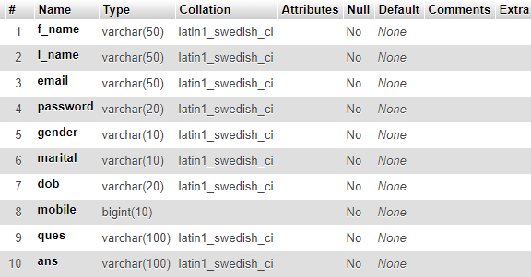USERS table has a attributes f_name ,I_name ,email,password,gender, marital,dob,mobile,ques,ans is used shown in table 2.1

**TABLE 1 STRUCTURE OF USER INFO**

## TRAIN_LIST

TRAIN_LIST table has atrributes number,name,origin,destination,arrival,departure, mon,tue,wed,thu,fri,sat,sun,1A,2A,3A,SL,General and number is used as a primary key as shown in table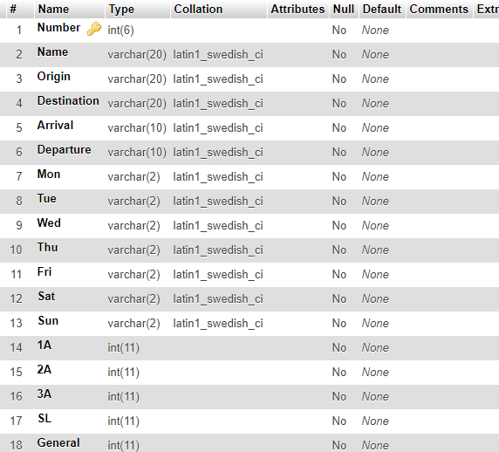

**TABLE 2 STRUCTURE OF TRAIN LIST**

## SEATS_AVAIBILITY

SEATS_AVAIBILTY table has the attribute train_no,train_name,doj,1A,2A,3A,AC,CC,SL is used shown in the table 2.3

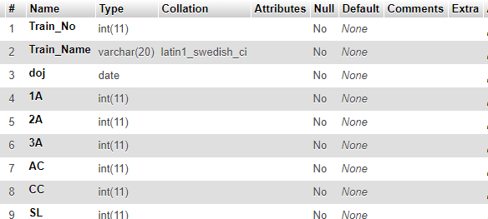

**TABLE 3 STRUCTURE OF SEATS_AVAIBILITY**

**ER DIAGRAM**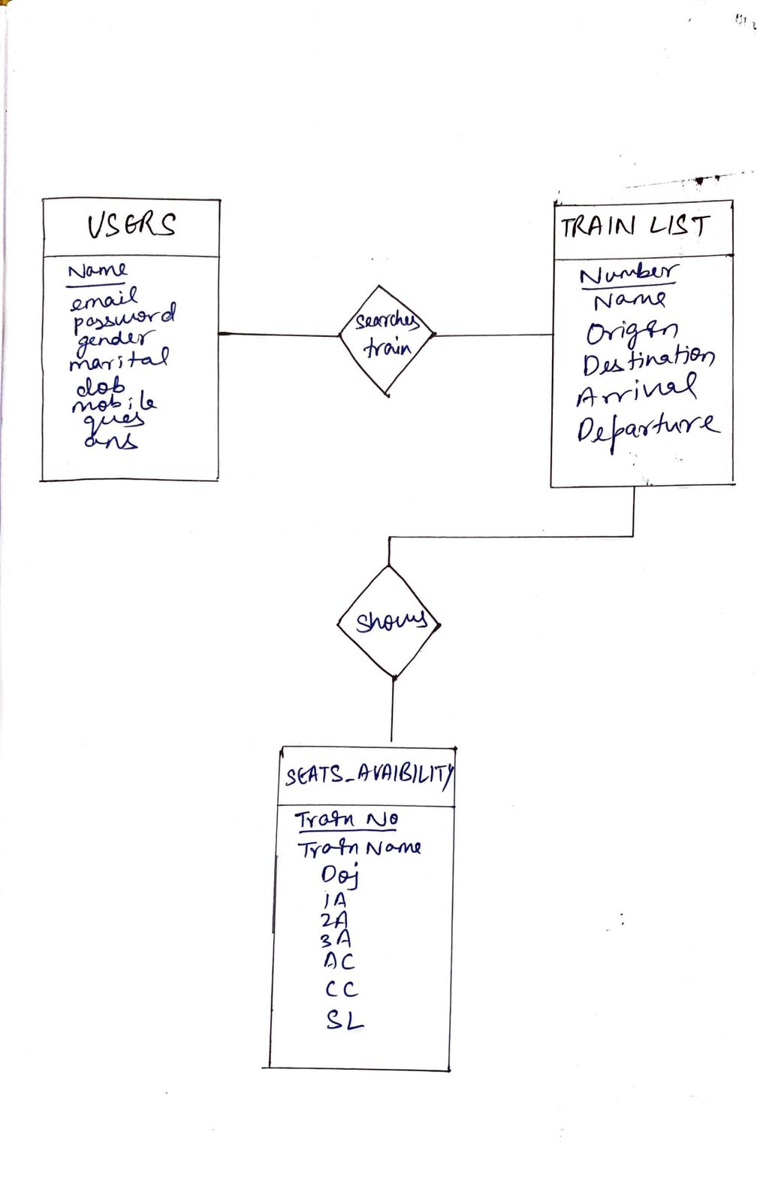

**CODE SNIPPETS**

## DATABASE CONNECTION

The connect() / mysqli_connect() function opens a new connection to the MySQL server with the following syntax :

mysqli_connect(*host, username, password, dbname, port, socket*)



**FIG A.1 DATABASE CONNECTION**

## INSERT QUERY

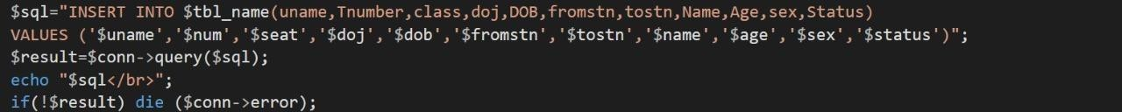This query is used to insert a booking .

**FIG A.2 INSERT QUERY**

## SELECT QUERY

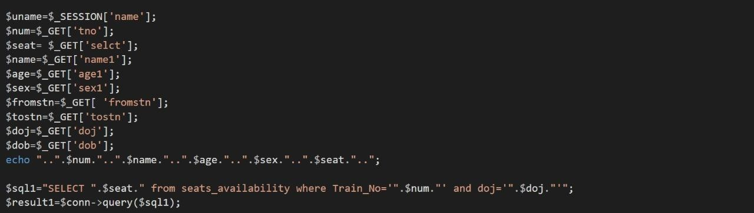In this query,all the details are fetched using SELECT* command

**FIG A.3 SELECT QUERY**

## UPDATE QUERY

Here the update query is called to update the user of an already existing based on its name and category id,address etc respectively.

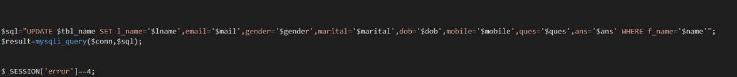

**FIG A.4 UPDATE QUERY**

**SCREENSHOTS-WEBSITE**

**HOMEPAGE**

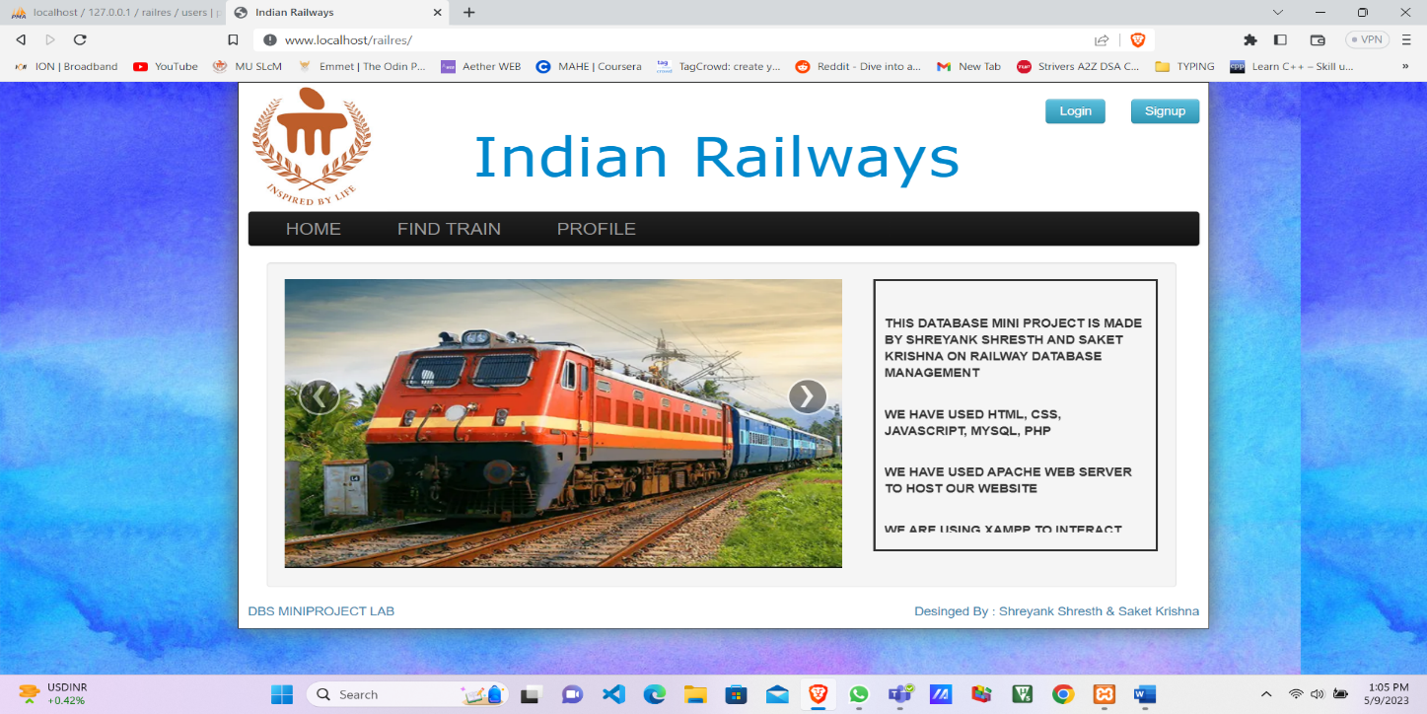

**FIND TRAIN PAGE**

**LOGIN PAGE**

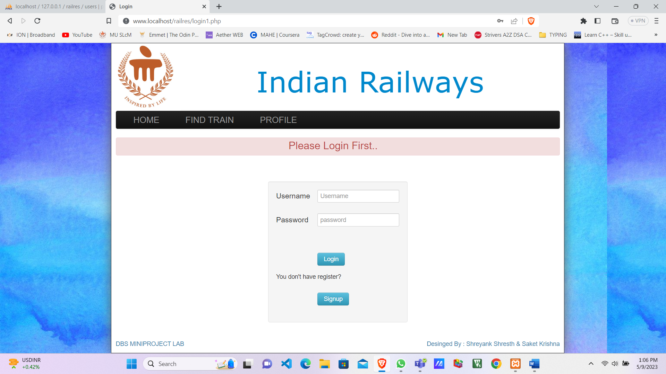

**SIGN UP PAGE**

**PROFILE INFO**

**REFERENCES**

1. <http://php.net/>
2. https://[www.](http://www/)<http://en.wikipedia.org/wiki/PHP>
3. https://[www.w3shools.com](http://www.w3shools.com/)
4. [www.youtube.com](http://www.youtube.com)

**MADE BY**

**SHREYANK SHRESTH**

**CSE -D**

**ROLL NO. 59**

**REG NO. 210905360**

**SAKET KRISHNA**

**CSE – D**

**ROLL NO. 51**

**REG NO. 210905316**